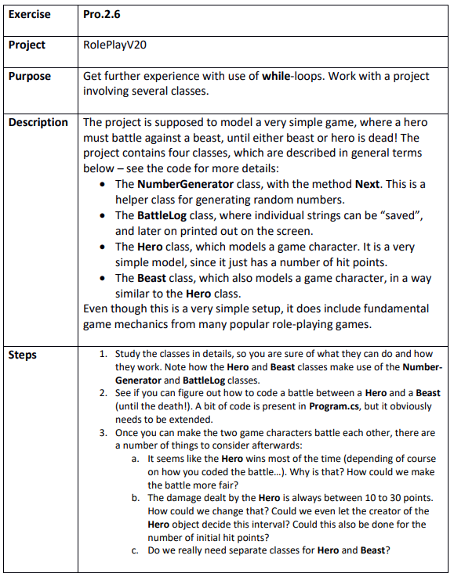

Step 1
RolePlayV20.sln
The hero and beast classes use the random generator and log only when dealing and receiving damage

Step 2
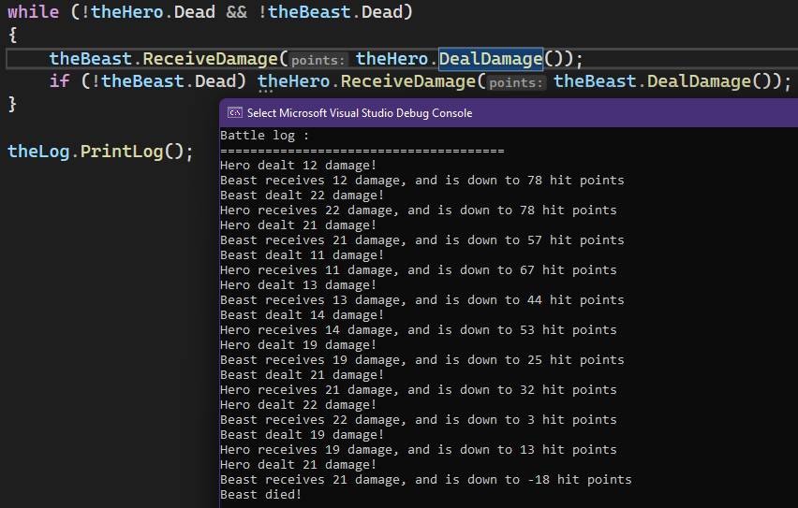

Step 3
- The hero has more hp on start and the hero can do up to 30 dmg instead of the max of 25 for the beast.
The fight would be more fair if we let the beast take the initiative with the first attack.
- We could change the amount of damage, that the hero deals within its DealDamage method.
We could add parameters in the heros constructor to make its starting hitpoint and min/max dmg changeable.
- No we don’t. The two classes are very similar and does the same things. This could be done with one class with an added field string type or similar and then with the hp, min/max dmg as parameters as well to make them different from each other.

